Intelligent Personal Finance Management System
CO2 Scenario-Based Requirement Analysis
Student Name | Pradhap J | Registration Number | 1924260246
Course | Software Engineering | Submission Date | 26-10-2026
Assessment | CO2 Requirement Analysis | Document Type | Requirements Analysis in Software
Purpose. This document analyzes the assigned scenario and defines a complete, testable requirement baseline for an Intelligent Personal Finance Management System. It explains the business problem, identifies the stakeholders and system behavior, and provides the information needed to design and validate the proposed solution.

1 Study and Analyze the Scenario

1.1 Business domain and scenario
The proposed system belongs to the personal finance and digital financial wellness domain. It gives an individual one secure place to record income, expenses, accounts, budgets, savings goals, and recurring payments. Transactions may be entered manually or imported from an approved financial data provider. The system then categorizes spending, summarizes cash flow, highlights unusual activity, and presents practical guidance through a dashboard and notifications.
The central need is to convert fragmented financial records into understandable, timely decisions. The solution is therefore more than a transaction register: it combines data capture, classification, planning, reporting, and privacy controls in a single user-oriented service.

1.2 Stakeholders
Stakeholder | Interest and responsibility
Individual user | Tracks finances, sets budgets and goals, reviews insights, and controls consent.
Administrator or support staff | Manages accounts, categories, policy settings, service health, and support requests.
Financial data provider | Authenticates approved account connections and supplies transaction data through an external interface.
Notification service | Delivers budget alerts, reminders, security messages, and goal updates.
Institution or evaluator | Checks that the requirements are complete, consistent, traceable, and suitable for implementation.

1.3 Existing challenges
- Financial information is spread across bank accounts, payment applications, spreadsheets, and paper records.
- Manual classification is slow and inconsistent, so users may not understand where money is being spent.
- People often notice overspending, missed bills, or weak saving progress only after the problem has occurred.
- Sensitive financial data requires strong access control, secure integration, clear consent, and reliable audit records.

1.4 System objectives
- Provide a single, accurate view of personal cash flow and account activity.
- Help users plan spending with budgets, savings goals, recurring-payment reminders, and understandable reports.
- Protect privacy and preserve data integrity while supporting secure external data integration.
- Create a maintainable and scalable foundation that can support additional accounts, categories, and insights later.

2 Functional and Non-Functional Requirements
Requirement identifiers provide traceability from the scenario to design, testing, and validation. Functional requirements describe what the system must do. Non-functional requirements describe the quality targets and operating conditions that make those functions trustworthy.

2.1 Functional requirements
ID | Requirement
FR-01 | The system shall allow a user to register, log in, log out, reset a password, and manage an authenticated session.
FR-02 | The system shall allow the user to maintain profile details, preferred currency, time zone, notification choices, and consent settings.
FR-03 | The system shall allow the user to connect an approved financial account or import a supported transaction file, with clear consent before data transfer.
FR-04 | The system shall store, search, filter, edit, and categorize income and expense transactions, while retaining a record of the source and update time.
FR-05 | The system shall allow the user to create, edit, pause, and monitor category budgets, savings goals, recurring payments, and target dates.
FR-06 | The system shall calculate balances, cash-flow summaries, category totals, budget progress, and goal progress for a selected period.
FR-07 | The system shall generate alerts for approaching budget limits, missed or upcoming recurring payments, unusual transactions, and goal milestones.
FR-08 | The system shall provide downloadable or printable reports for transactions, budgets, cash flow, and savings progress.
FR-09 | The system shall allow the user to correct categories, mark transactions as reviewed, and record notes without changing the original imported source.
FR-10 | The system shall provide authorized administrators with account support, category management, audit review, and service-configuration functions.

2.2 Non-functional requirements
ID | Quality attribute | Requirement target
NFR-01 | Performance | For normal load, 95% of dashboard and search requests should return within 3 seconds.
NFR-02 | Security | Use encrypted transport, secure password hashing, least-privilege access, session timeout, and audit logging for sensitive actions.
NFR-03 | Privacy | Collect only necessary data, obtain explicit account-link consent, and let the user revoke consent and request deletion where permitted.
NFR-04 | Reliability | Use validation, duplicate detection, backups, and transaction-safe updates so calculations remain accurate after failures.
NFR-05 | Usability | A first-time user should be able to add a transaction, set a budget, and find the dashboard without training.
NFR-06 | Scalability | The service should support growth in users, accounts, transactions, and notification volume without redesigning core interfaces.
NFR-07 | Maintainability | Separate interface, business logic, data, and integration layers; document APIs, rules, and testable acceptance criteria.
NFR-08 | Availability | Target 99.5% monthly availability excluding approved maintenance, with monitored recovery from service or provider failures.

3 Actors and Use Cases
The User is the primary actor because all core value is delivered through personal financial planning and review. The Administrator supports safe operation. The Financial Data Provider and Notification Service are secondary actors that exchange data with the system through controlled interfaces.
Actor | Major use cases
User | Register or log in; manage profile and consent; link accounts or import transactions; review and categorize transactions; set budgets and goals; view dashboard; receive alerts; generate reports.
Administrator | Support users; manage categories and rules; review audit records; monitor integrations; configure service policies.
Financial Data Provider | Authenticate account connection; return account and transaction data; report token, permission, or synchronization errors.
Notification Service | Deliver budget alerts, goal reminders, payment reminders, and security messages; return delivery status.

3.1 Use case diagram
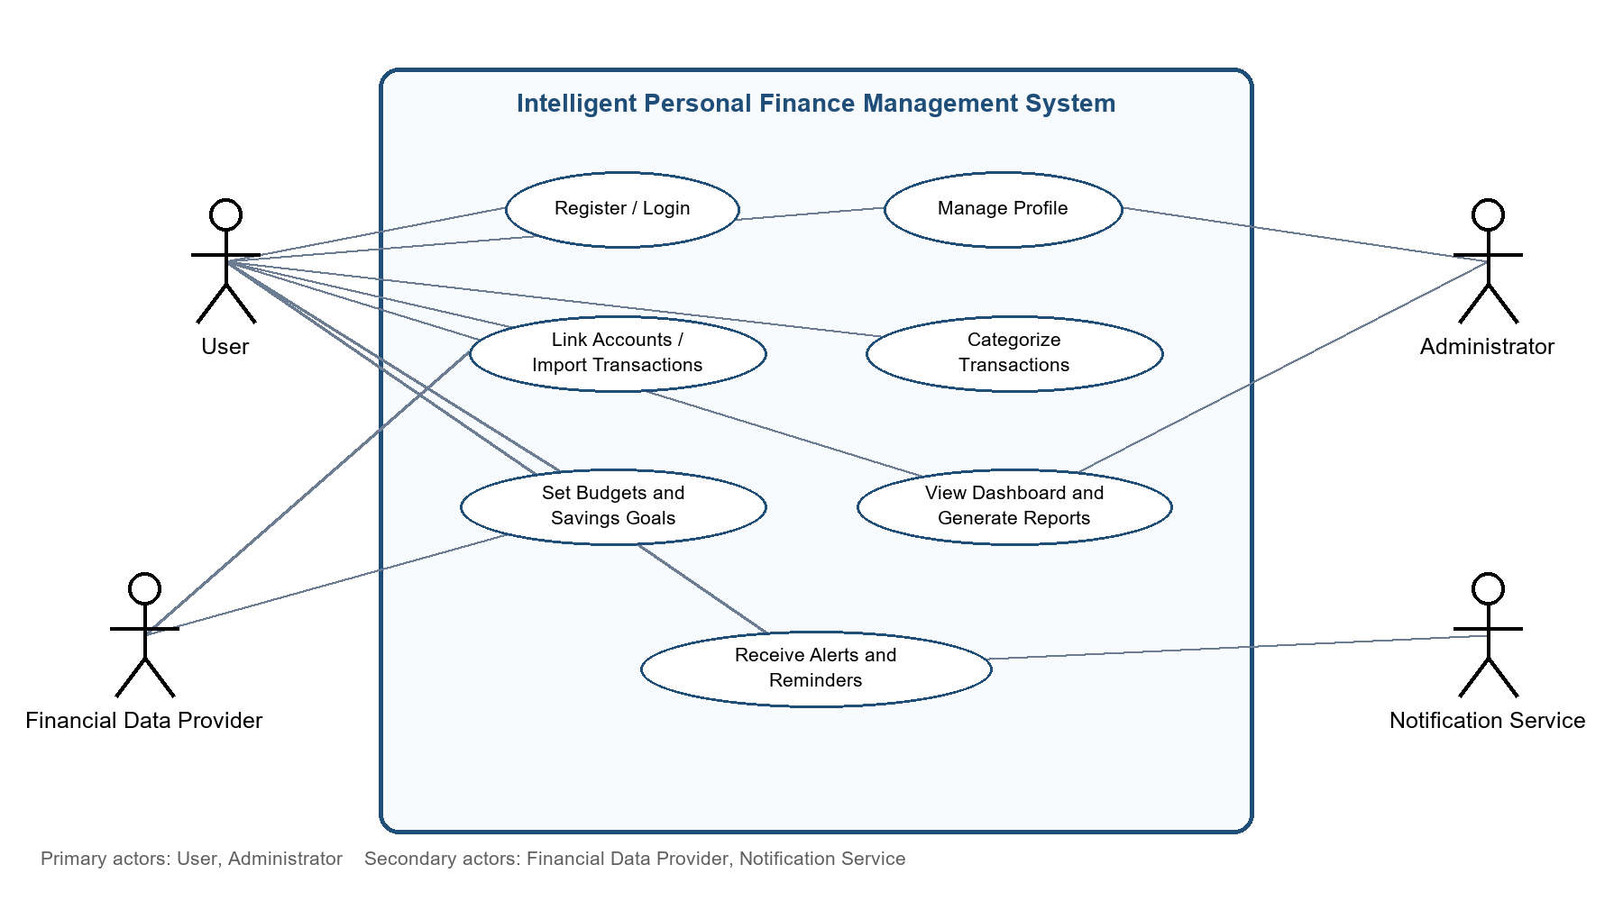
Figure 1. Use case diagram for the proposed system

3.2 Selected use case summaries
Use case | Primary flow and result
UC-01 Register or log in | The user submits credentials; the system validates them, starts a secure session, and shows the dashboard. Invalid credentials produce a clear error without revealing sensitive details.
UC-02 Link account or import transactions | The user gives consent, completes provider authentication or selects a supported file, and the system validates, deduplicates, stores, and summarizes the received transactions.
UC-03 Set budget or savings goal | The user chooses a category or goal, amount, period, and target date. The system validates the values, stores the plan, and calculates progress against later transactions.
UC-04 Review dashboard and alerts | The system calculates current summaries and displays trends. When a threshold or due date is reached, it creates an alert and sends it through the selected notification channel.

4 Software Requirement Specification

4.1 Introduction
This SRS defines the baseline behavior and quality expectations for the Intelligent Personal Finance Management System. It is intended for the student analyst, developers, testers, administrators, and reviewers. The document is implementation-neutral: it specifies required outcomes while leaving the choice of framework, database, and deployment platform to the design stage.

4.2 Problem description
Users need a dependable way to understand income, expenses, budgets, and savings across multiple sources. Existing manual methods create duplicated records, delayed decisions, and weak visibility of recurring commitments. The proposed system addresses this gap with secure data capture, consistent categorization, planning tools, and timely feedback.

4.3 Scope of the system
In scope | Out of scope for the first release
User registration and authentication; profile and consent management; manual entry and approved import; transaction categorization; budgets, goals, recurring payments; dashboard, reports, alerts, and administrative support. | Investment trading, loan approval, tax filing, credit scoring, financial advice that requires a licensed adviser, and direct movement of money between accounts.

4.4 Use case descriptions
Account access. The user authenticates before viewing personal data. The system rejects invalid or expired sessions and records security events. Account linking. The system obtains consent before requesting provider data, validates the provider response, and reports synchronization errors without losing existing records. Budget monitoring. The system compares categorized transactions with the user's active budget and creates a notification when a configured threshold is reached. Report generation. The user selects a period and report type; the system returns a consistent summary and supports export without exposing another user's data.

4.5 Data requirements
Entity | Required information and rules
User and consent | User ID, contact, hashed credential, preferences, consent scope, consent time, and status. Access is limited to the owner or authorized administrator.
Account and transaction | Account reference, provider reference, date, amount, currency, description, source, category, review status, and synchronization timestamp. Provider identifiers must support duplicate detection.
Budget, goal, and payment | Name, category or purpose, amount, period, target date, progress, active status, and reminder settings. Values must be validated for currency and date consistency.
Audit and notification | Actor, event, time, result, delivery channel, delivery status, and retry details. Sensitive values must not be written to ordinary logs.

4.6 External interface requirements
- User interface: responsive screens for authentication, dashboard, transactions, budgets, goals, reports, settings, and consent.
- Financial provider interface: authenticated API or supported file format with timeout, retry, validation, and error handling.
- Notification interface: email, in-app, or approved messaging channel with delivery status and user preferences.

4.7 System features
The feature set is organized around four outcomes: accurate records, meaningful planning, timely feedback, and controlled access. Each feature must map to the identifiers in Section 2 and have acceptance tests for normal, invalid, duplicate, and unavailable-service conditions.

5 Assumptions and Constraints

5.1 Assumptions
ID | Assumption
A-01 | Users have access to a supported web or mobile device and a stable internet connection for synchronization.
A-02 | Users provide accurate profile, budget, goal, and manual transaction information.
A-03 | The external financial provider exposes a documented, permission-based interface or a supported export format.
A-04 | Currency and date rules are available for each connected account and can be normalized for reporting.
A-05 | Notification channels are available and the user can opt in, opt out, or change preferences.
A-06 | The service is used for planning and tracking; it does not execute payments or replace regulated financial advice.

5.2 Constraints
Category | Constraint and effect
Technical | Provider rate limits, changing API schemas, synchronization failures, device differences, and the need to protect secrets restrict integration design.
Operational | Support staff need monitoring and recovery procedures; users need understandable error messages when a provider or notification channel is unavailable.
Economic | Hosting, provider access, messaging, security monitoring, and maintenance costs must remain appropriate for the expected user base.
Legal and privacy | Personal financial data requires consent, purpose limitation, access control, retention rules, and compliance with applicable privacy and financial regulations.
Time and scope | The first release must prioritize secure tracking, planning, and reporting; advanced predictions and automated advice are deferred.

6 Validate Requirement Completeness and Consistency
Validation checks whether the requirement set is understandable, non-contradictory, and sufficient for design and testing. The review below uses the scenario, stakeholder list, requirement identifiers, use cases, data model, and constraints as a traceability chain.
Validation check | Result and improvement
Stakeholder coverage | Complete for the defined scope: the User, Administrator, Financial Data Provider, and Notification Service each have responsibilities and use cases. Confirm provider-specific permissions during design.
Functional completeness | Core capture, categorization, planning, dashboard, alerts, reporting, and administration are represented by FR-01 to FR-10. Add acceptance criteria for each requirement before implementation.
Non-functional completeness | Performance, security, privacy, reliability, usability, scalability, maintainability, and availability are represented by NFR-01 to NFR-08. Convert targets into measurable test cases.
Ambiguity and redundancy | Terms such as approved provider, unusual transaction, and supported file must be defined in the design glossary. Imported source data and user corrections are intentionally kept separate.
Consistency and traceability | The use cases, data entities, interfaces, and scope align with the functional requirements. Link every future design component and test case to an FR or NFR identifier.
Missing requirement risk | Accessibility, localization, retention duration, and recovery-point targets require stakeholder confirmation before a production release. Record decisions as revised requirements.
Conclusion. The proposed SRS is complete enough to begin high-level design and prototyping. Its main follow-up actions are to confirm provider-specific permissions, define measurable acceptance criteria, and obtain stakeholder decisions on accessibility, localization, data retention, and disaster recovery targets.

